

**SANYO SN-24UA74 1.5 Ton**

**Rs. 254,800/-**

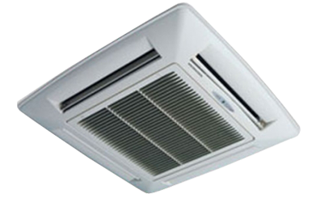

**Product Features**

* power mode
* precise system control technology
* concealed LED display
* Intelligent airflow
* precise system control technology

**Specification**

**Type** Ceiling Cassette AC

**Cooling (Btu/h)** 38000

**Voltage (V)** 220-240

**Power Input (W)** 4800

**EER (Btu/W-h-W/W)** 6.7-3.5